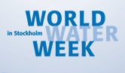
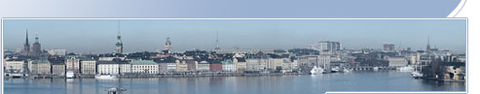

World Water Week General
Plenaries
Workshops
Seminars and Side Events
Technical Tours
Social Events
Prizes and Awards

World Water Week in Stockholm
20-26 August, 2006
Building Capacity – Promoting Partnership –
Reviewing Implementation
The World Water Week in Stockholm is the leading annual global meeting place for capacity-building, partnership-building and follow-up on the implementation of international processes and programmes in water and development. It includes topical plenary sessions and panel debates, scientific workshops, independently organised seminars and side events, exhibitions and festive prize ceremonies honouring excellence in the water field. Stockholm is the meeting place for experts from businesses, governments, the water management and science sectors, inter-governmental organisations, NGOs, research and training institutions and United Nations agencies.

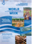
Download the 2006 World Water Week Final Programme Click here >>

Register online Click here >>
The World Water Week in Stockholm is arranged by SIWI
Contact Info
E-mail: sympos@siwi.org
Phone. +46 (0)8 522 139 60

Registration is Open
Online registration is now open!
Read more >>
WWW Topic Previews
Click on the link below to read more about some of the topics that will be covered during the World Water Week in Stockholm.
Read more >>

News
Full Programme Now Available
06-05-03
The 2006 World Water Week in Stockholm will continue its important role at the nexus of the water, environment, development and poverty reduction fields when it takes place August 20-26 at the Stockholm City Conference Centre in the Swedish capital. The full programme can now be found in the printed Second Announcement and Call for Registration, and also at this website.
Read more >>

